**PATTERN BASED C QUERIES**

Pattern 1  **Right Half Pyramid**

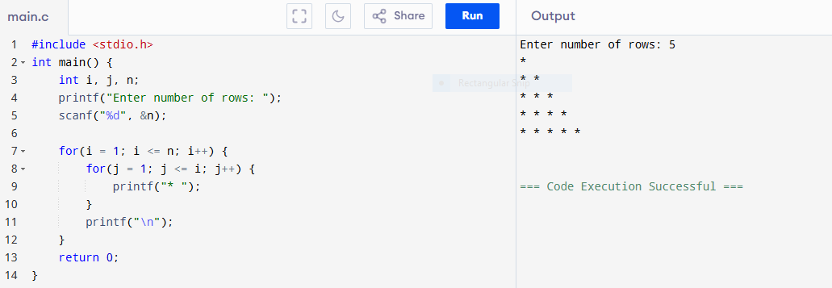

Pattern 2 **Left Half Pyramid**

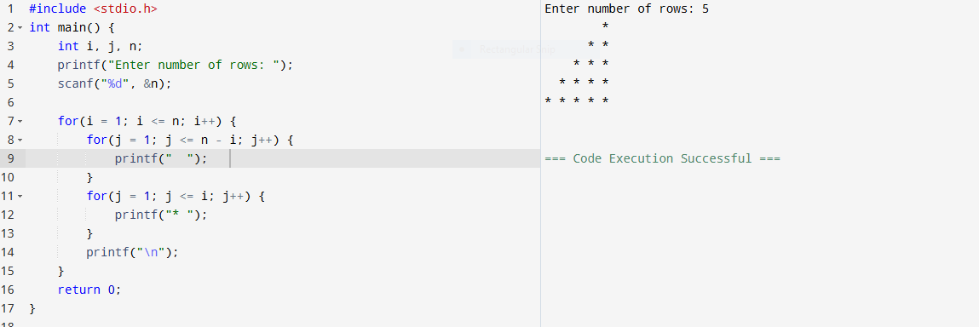

Pattern3 **Full Pyramid**

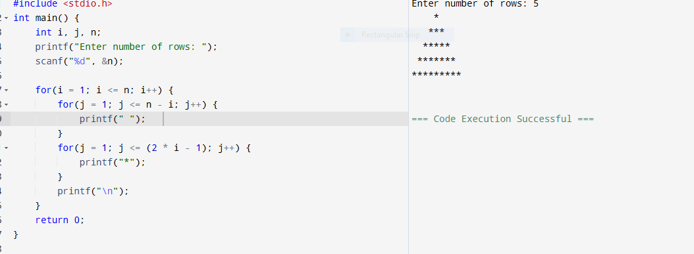

Pattern4 **Inverted Right Half Pyramid**

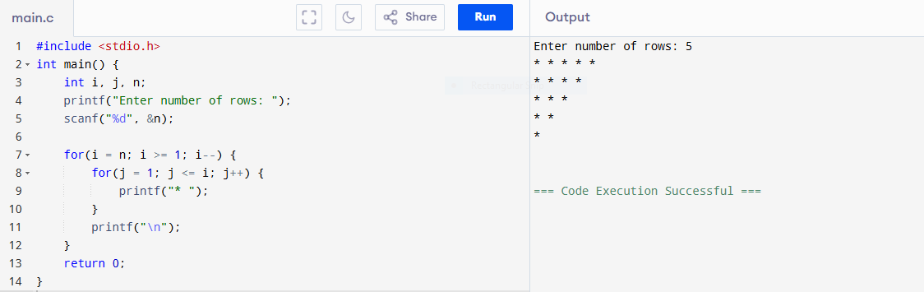

Pattern 5 **Inverted Left Half Pyramid**

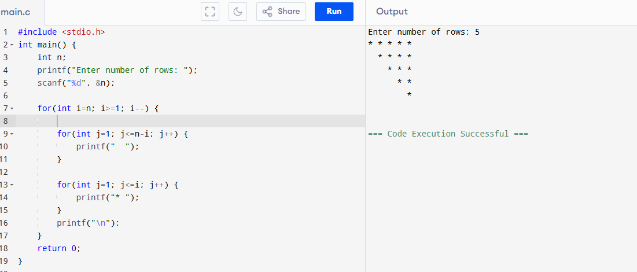

Pattern 6 **Inverted full**

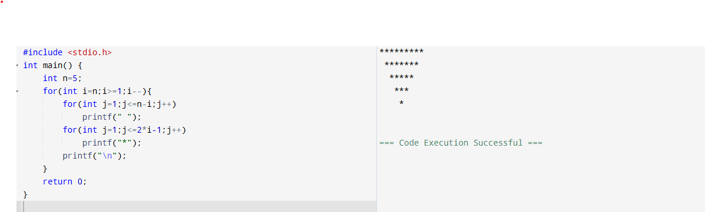

Pattern 7 **RHOMBUS Pattern**

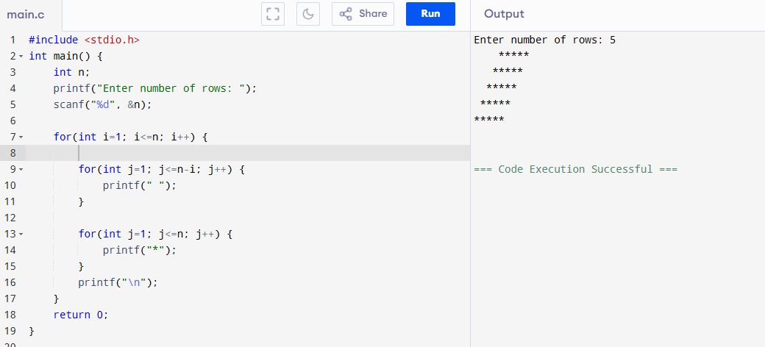

Pattern 8 **Diamond pattern**

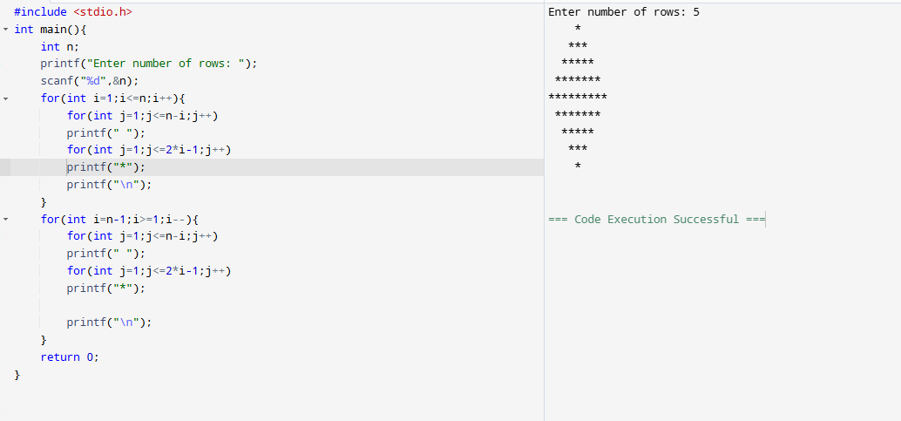

**PATTERN 9 Hour Glass Pattern**

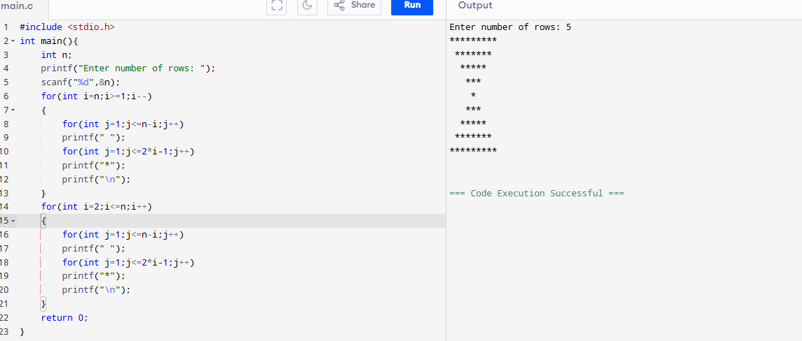

**Pattern 10 Hollow square**

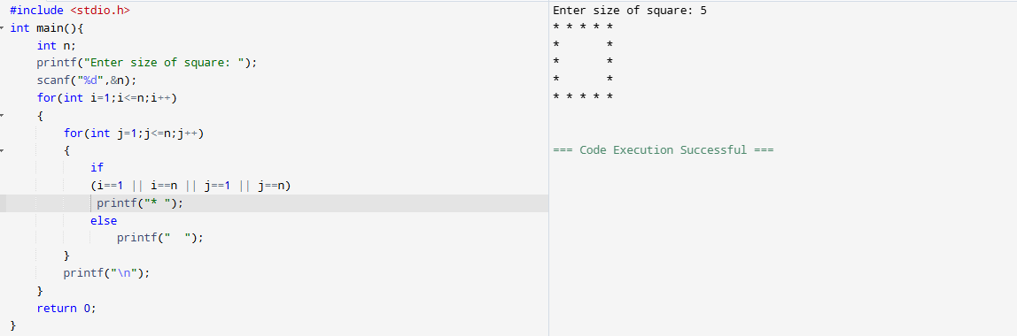

**Pattern 11 Hollow Full Pyramid**

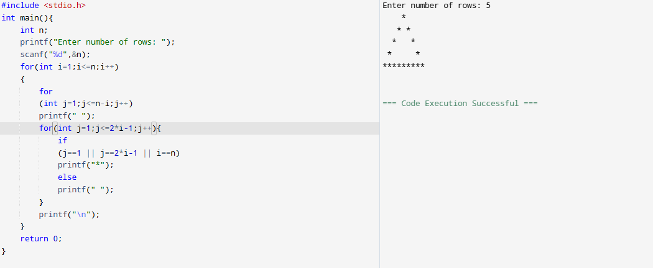

**Pattern 12 Hollow inverted full pyramid**

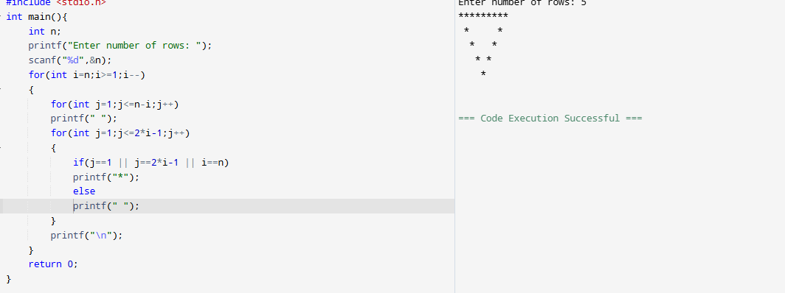

**Pattern 13 Hollow Diamond**

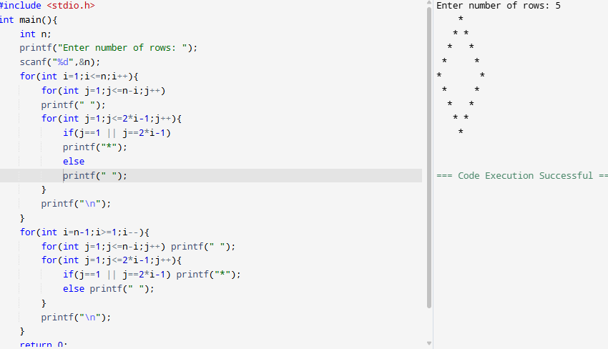

**Pattern 14 Floyd’s Triangle**

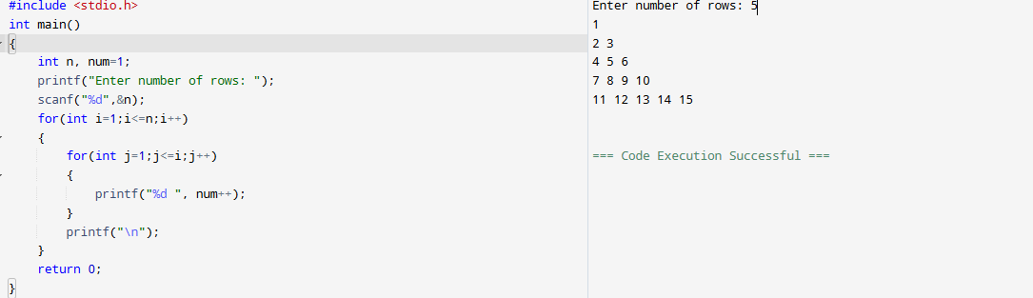

**Pattern15 Hollow Hour glass pattern**

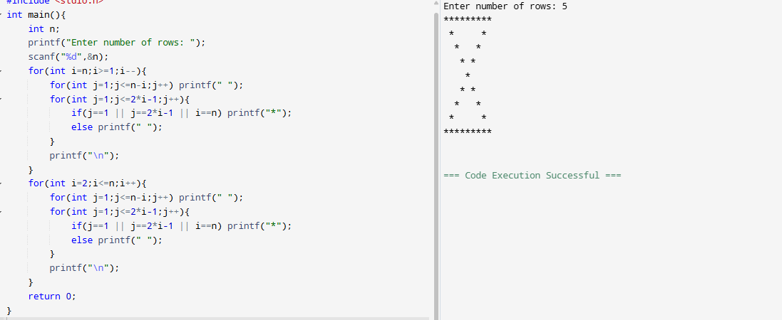

**Pattern 16 Pascal’s triangle**

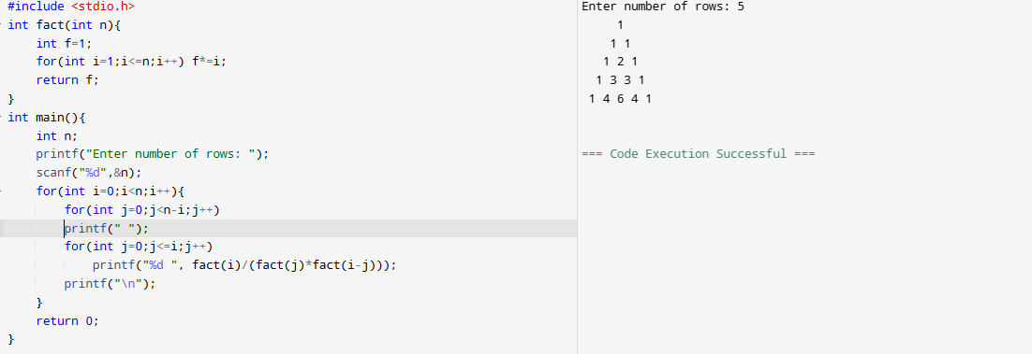

**PATTERN 17**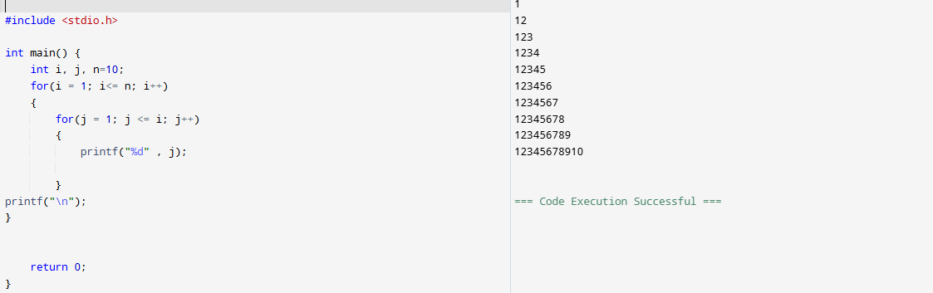

**Pattern 18**

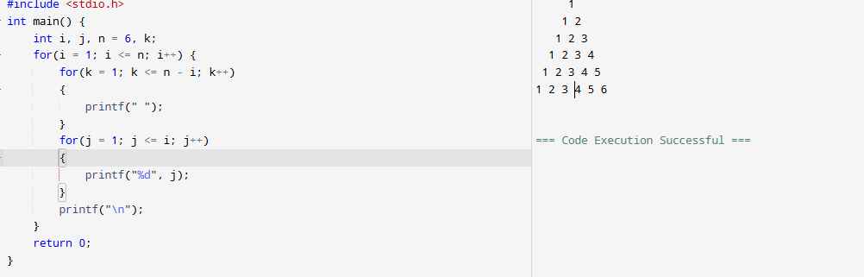

**Pattern 19**

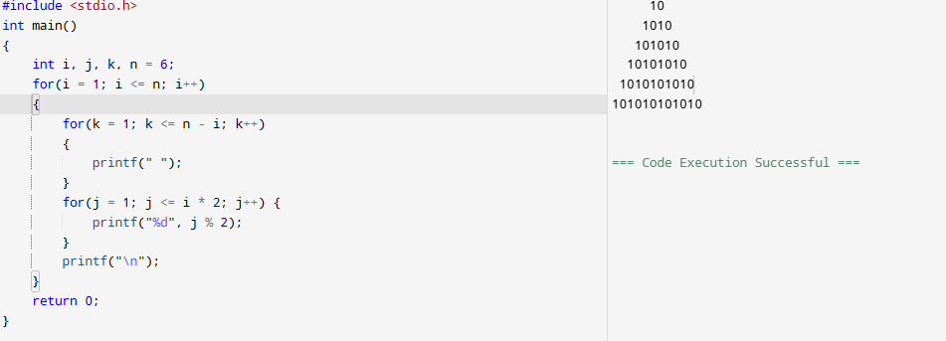

**Pattern 20**

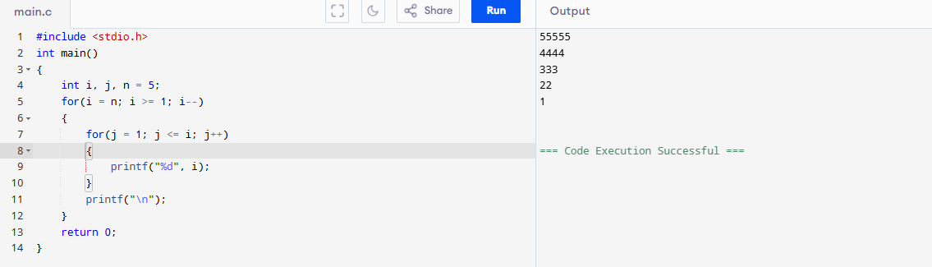

**Pattern 21**

